Question#01:

a) Explain decoder and encoder.

Decoder

The decoder is an electronic device that can modify a digital signal to an analog signal. It enables a single input line and creates multiple output lines. The decoders are used in several communication projects that are connected between two devices. The decoder enables N- inputs and creates 2 power N-numbers of outputs. For instance, if it can provide 2 inputs that will make 4 outputs by using 4 by 2 decoder.

There is only one output that can be similar to zero at any given time, all several outputs being similar to one. The outputs define the minterm choose by the inputs A1 and A0. The circuit is disabled when E’ is similar to one, unconcerned of the values of the additional two inputs. If the circuit is disabled, then none of the outputs are similar to zero.

Encoder

A digital circuit that executes the inverse services of a decoder is known as an encoder. It has 2n input lines and n output lines. In an encoder, the output lines create the binary code equivalent to the input value. The figure displays the general architecture of an encoder circuit.

b) Write applications of both decoder and encoder

Application of decoder

They are commonly used in various electronic devices and systems for different applications. Some common applications of decoders include:

1. Memory Systems: Decoders are often used in memory systems to select specific memory locations for reading or writing data. For example, in RAM (Random Access Memory) chips, decoders are used to select the specific memory cell based on the address provided by the memory controller.
2. Display Systems: In display systems, decoders are used to select specific segments of a display to be activated. For example, in a 7-segment display, a decoder is used to convert a binary input into signals that activate the appropriate segments to display numbers or characters.
3. Address Decoding: Decoders are used in microprocessors and other digital systems to decode memory or I/O addresses. They are used to enable specific memory or I/O devices based on the address provided by the processor.
4. Digital Communication Systems: Decoders are used in digital communication systems to decode encoded data transmitted over a communication channel. For example, in error detection and correction systems, decoders are used to decode error-correcting codes to detect and correct errors in the transmitted data.
5. Remote Controls: In infrared remote controls, decoders are used to decode the signals sent by the remote control handset and convert them into commands that can be understood by the controlled device, such as a TV or a set-top box.

Applications of Encoders

* Computer System

1. Speed Synchronization of Motors
2. CNC Machiner
3. Industry
4. Medical
5. Data routing

### Computer Systems

The encoders are used in microprocessor and control unit in computer systems. Microprocessors uses encoders for detecting the interrupts and in its control units. The encoder may help to manage the interrupts coming from other devices to the microprocessor. The priority encoders are used in the microprocessors to prioritize the interrupts.

### Speed Synchronization of Motors

The encoders are also used as the speed synchronizers for the multiple motors working together in an industry. The speed of different motors is different within the same point of time, so the encoders are used to get synchronization between these motors.

### CNC Machiner

Encoders are used in CNC machineries as an essential part that works together for drills, bores and mills.

### Electronics Industry

Encoders are used in the electronics industry to fabricate the semiconductors. The different types of encoders like rotatory encoders, angle encoders and linear encoders are used in the electronic industries.

### Medical

Encoders are highly used in medical fields and machines like CT scan, MRI etc. The rotatory encoders are used in these types of machines to get the correct and safe treatments.

### Data Routing

The encoder are used in communication systems for the data routing. The encoder helps the data to be passed through the link with small bandwidth and further the data can be decoded once reached to the desired destination.

c) Write appropriate example for both decoder and encoder.

Example of decoder

Decoders are used to convert or to identify a particular code, for example: Binary to Octal (3 to 8-line decoders) Binary to Hexadecimal (4 to 16 line decoders) BCD to Decimal (4 to 10 line decoders.

Example of encoder

An example of the encoder is the Octal to Binary encoder.

Question#02:

a) Explain Multiplexers and Demultiplexers.

Multiplexers

A multiplexer is a combinational circuit that has many data inputs and a single output, depending on control or select inputs. For N input lines, log2(N) selection lines are required, or equivalently, for 2𝑛2*n* input lines, n selection lines are needed. Multiplexers are also known as “N-to-1 selectors,” parallel-to-serial converters, many-to-one circuits, and universal logic circuits. They are mainly used to increase the amount of data that can be sent over a network within a certain amount of time and bandwidth.

Types of Mux

The Mux can be of different types based on input but in this article we will go through two major types of mux which are

* 2×1 Mux

1. 4×1 Mux

## Demultiplexer?

A demultiplexer is a combinational logic circuit that accepts a single input and distributes it over several output lines. Demultiplexer is also termed as DEMUX in short. As demultiplexer is used to transmit the same data to different destinations, hence it is also known as data distributor.

It can be seen that the demultiplexer has only one data input line, 2n output lines, and n select lines. The logic level applied to select lines of the demultiplexer determines the output channel to which the input data will be transmitted.

Demultiplexer circuit are the combinational logic circuit widely used in digital decoders and Boolean function generator circuits.

## Types of Demultiplexers

* 1:2 Demultiplexer
* 1:4 Demultiplexer
* 1:8 Demultiplexer

### 1

b) Write applications of both multiplexer and demultiplexer

## Applications of MUX

Given Below are the Applications of MUX

* **Data Routing**: The Mux is used for data routing in the digital system where they select one of the several data lines and re-route it the output.

1. **Data Selection**: The Mux is used for data selection where they select data source according to the select lines.
2. **Analog-to-Digital Conversion**: The Mux are used in ADC to select different analog input channels.
3. **Address Decoding**: The Mux are used in Microprocessor or memory for address decoding.
4. **Logic Function Implementation**: Muxes can be used to implement various logic functions.

## Applications of Demultiplexers

Demultiplexer is a crucial combinational logic circuit which is used in a number of applications. Some important uses of demultiplexers are listed below −

* Demultiplexers are used in several input and output devices for data routing.
* Demultiplexers are used in digital control systems to select one signal from a mutual stream of signals.
* Demultiplexers are also employed for data transmission in synchronous systems.
* Demultiplexers are also utilized in data acquisition systems.
* Demultiplexers can be used for generating Boolean functions.
* Demultiplexers can be used in serial to parallel converters.
* Demultiplexers are used for broadcasting of ATM packets.
* Demultiplexers can also be used to design automatic test equipment, etc.

c) Write appropriate example for both,

Example of multiplexer

A simple example of a non-electronic circuit of a multiplexer is a single-pole multi position switch. Sharing a communication channel between several components in circuits.

Example of demultiplexer

within a computer system, a simple yet crucial example of De Multiplexer usage is managing memory. In computer memory systems, DeMUX can be deployed to select the precise memory cell in a RAM module for data read/write operations based on input address lines.

Write the truth table for a 2 to 1 MUX, design a circuit from it, implement it and verify the results.

|  |  |  |  |
| --- | --- | --- | --- |
| **S0** | **I0 (B)** | **I1 (A)** | **Y** |
| **1** | **X** | **0** | **0** |
| **1** | **X** | **1** | **1** |
| **0** | **0** | **X** | **0** |
| **0** | **1** | **X** | **1** |

**Circuit diagram**

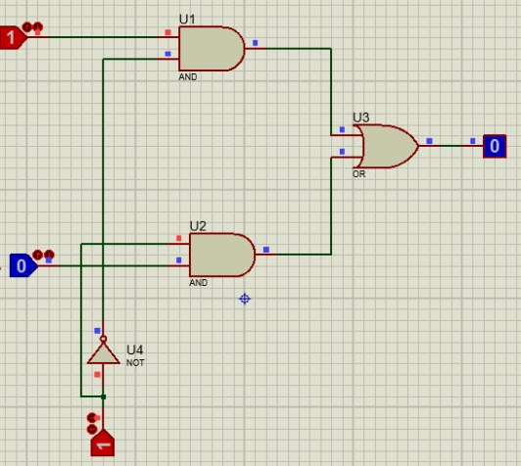

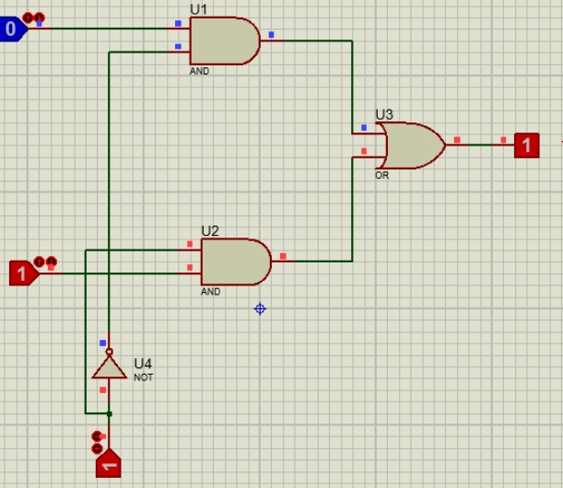

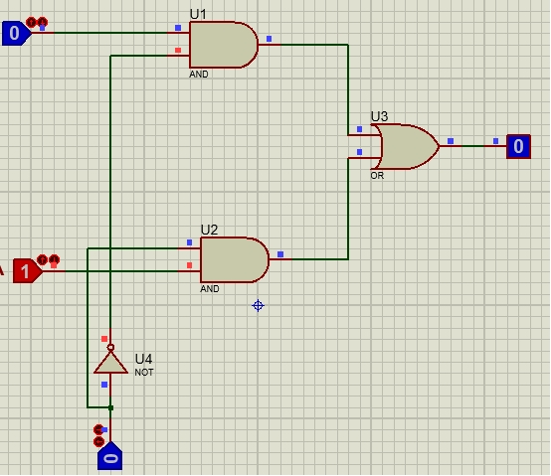

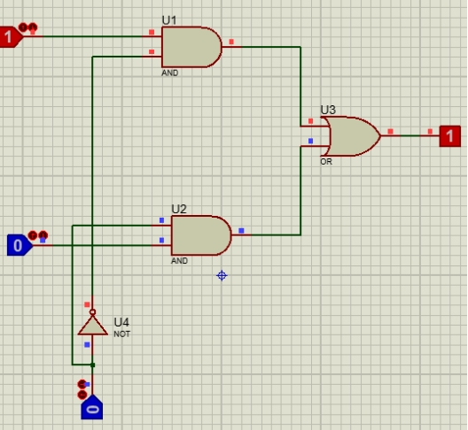

Write down the truth table for a 4 to 1 MUX, draw the circuit, implement it and verify the results.

|  |  |  |  |  |  |  |
| --- | --- | --- | --- | --- | --- | --- |
| **S1** | **S0** | **X3 (I3)** | **X2 (I2)** | **X1(I1)** | **X0 (I0)** | **Y** |
| 0 | 0 | X | X | X | 0 | 0 |
| 0 | 0 | X | X | X | 1 | 1 |
| 0 | 1 | X | X | 0 | X | 0 |
| 0 | 1 | X | X | 1 | X | 1 |
| 1 | 0 | X | 0 | X | X | 0 |
| 1 | 0 | X | 1 | X | X | 1 |
| 1 | 1 | 0 | X | X | X | 0 |
| 1 | 1 | 1 | X | X | X | 1 |

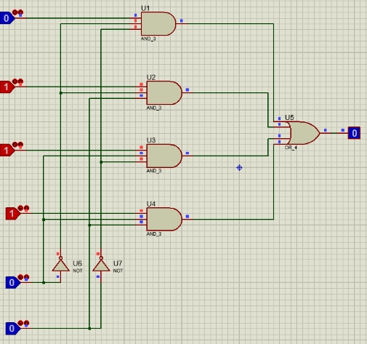

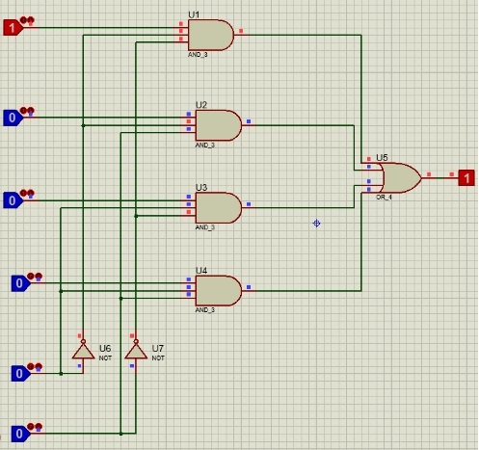

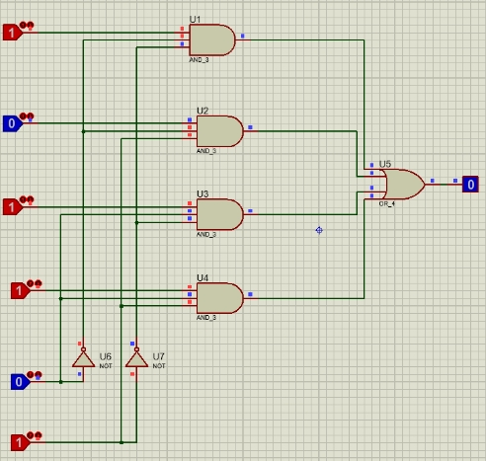

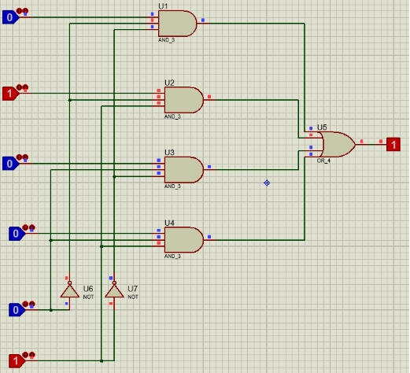

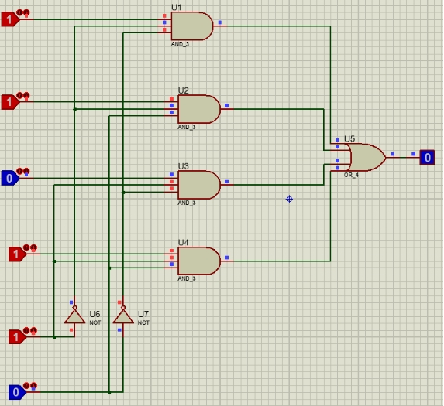

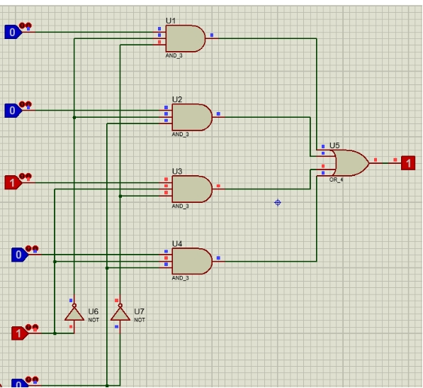

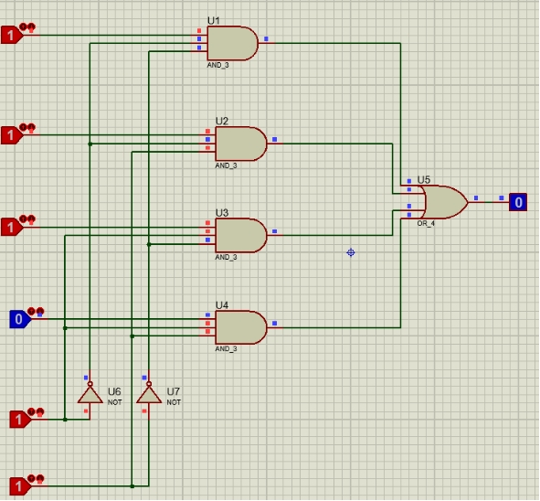

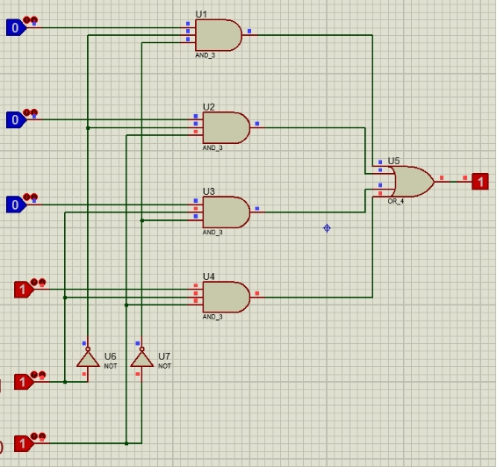

Q4: Implementation of a 2 to 4 Decoder

Write truth table for a 2 to 4 decoder with enable bit in it.

|  |  |  |  |  |  |  |
| --- | --- | --- | --- | --- | --- | --- |
| E | S1 | S0 | D3 | D2 | D1 | D0 |
| 0 | 0 | 0 | 0 | 0 | 0 | 1 |
| 0 | 0 | 1 | 0 | 0 | 1 | 0 |
| 0 | 1 | 0 | 0 | 1 | 0 | 0 |
| 0 | 1 | 1 | 1 | 0 | 0 | 0 |
| 1 | X | X | X | X | X | X |

Draw the gate diagram of a 2 to 4 decoder.

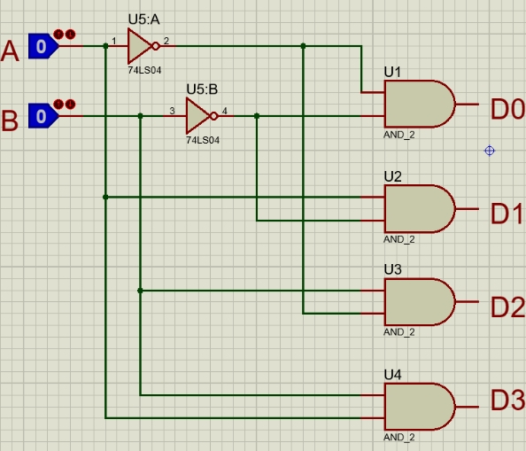

1. Implementation of a 2 to 4 decoder on trainer using three input AND gate with enable bit as active low and verify with truth table.

Below is the Implementation of a 2 to 4 decoder on trainer using three input AND gate with enable bit as active low and verify with truth table of Part a.

